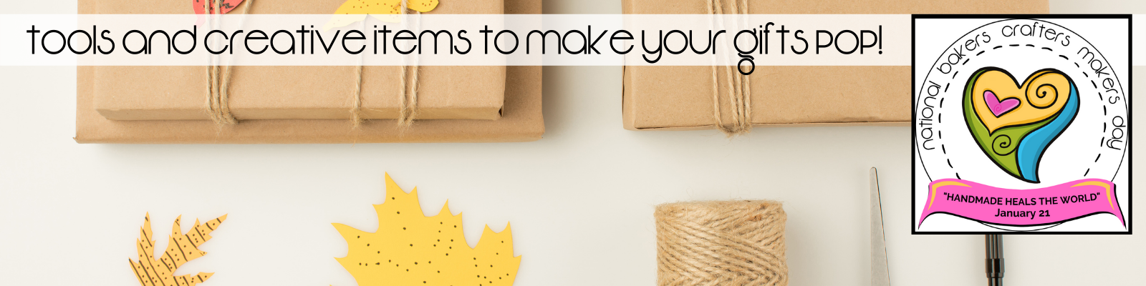

This download is meant to be used in conjunction with Anita Housman’s “Create Your Own Gift Wrapping Signature” class that can be found on the Gift Biz Unwrapped Facebook Page

Basic Tools:

Items to have on hand Scissors Scale if shipping
to jazz it up! Ruler/Tape Measurer Paper Cutter
Variety of Tape Elastic Wire
Glue Gun Twine/String
Wire Cutters Floral
Items/Decorative Trims

Optional Tools:
Nice to have... Elastic Wire Hole Punch
Wire Cutters Lighter
Rubber Stamps Paper Cutter
Curling/Flattening Iron

